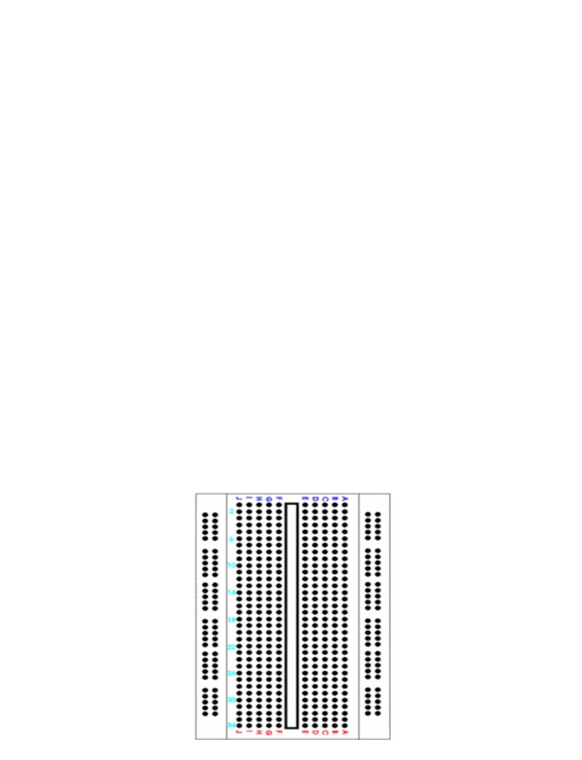
Breadboard Basics and Connections
What is Breadboard?
A breadboard is a circuit board that is used to make temporary circuits. It is a device having electronics and test circuit
designs. The electronic elements inside the electronic circuits can be interchanged by inserting the terminals and leads into
holes and later connecting it with the help of appropriate wires. The device has stripes of metal below the board that
connects the holes placed on the top of the board. The connections of the breadboard are mostly temporary and the
elements can further be reassembled and reused without any damage. Breadboards are generally used in electrical
engineering. Engineers make use of breadboards in order to test different products made by them. Using breadboard is the
most efficient way of testing and also they are cost effective. They can be reused again and again for the purpose of testing.
Today, starting from tiny analog, digital circuits to big complicated CPU’s everything can be tested with the help of this.
Breadboards earlier were made of copper wires or terminal strips. These days it is made up of white plastic and is a
breadboard that can be plugged. Breadboards are solderless and they are made of two kinds of strips i.e. terminal and bus
strips. Terminal strips help in holding the electronic elements while the bus strip is used to power electric power to all the
electronic components. You can find manufacturers selling solderless breadboards very easily, some manufactures sell the
bust and terminal strips separately and some sell it together.
Breadboard Basics:
A breadboard is a circuit which if of a temporary nature used for the purpose of testing and prototyping circuits. It is easy to
prototype circuits with the help of breadboards because it is fast and easy. Breadboards are generally used to test circuits.
As this device have holes in it. In order to form a circuit, wires are inserted simply inside the holes. An advantage of using a
breadboard is that the positions of the wires can be changed if they are placed in a wrong order. In the below diagram you
can see alphabets are used in order to identify vertical columns and numbers are used in order to identify vertical columns.
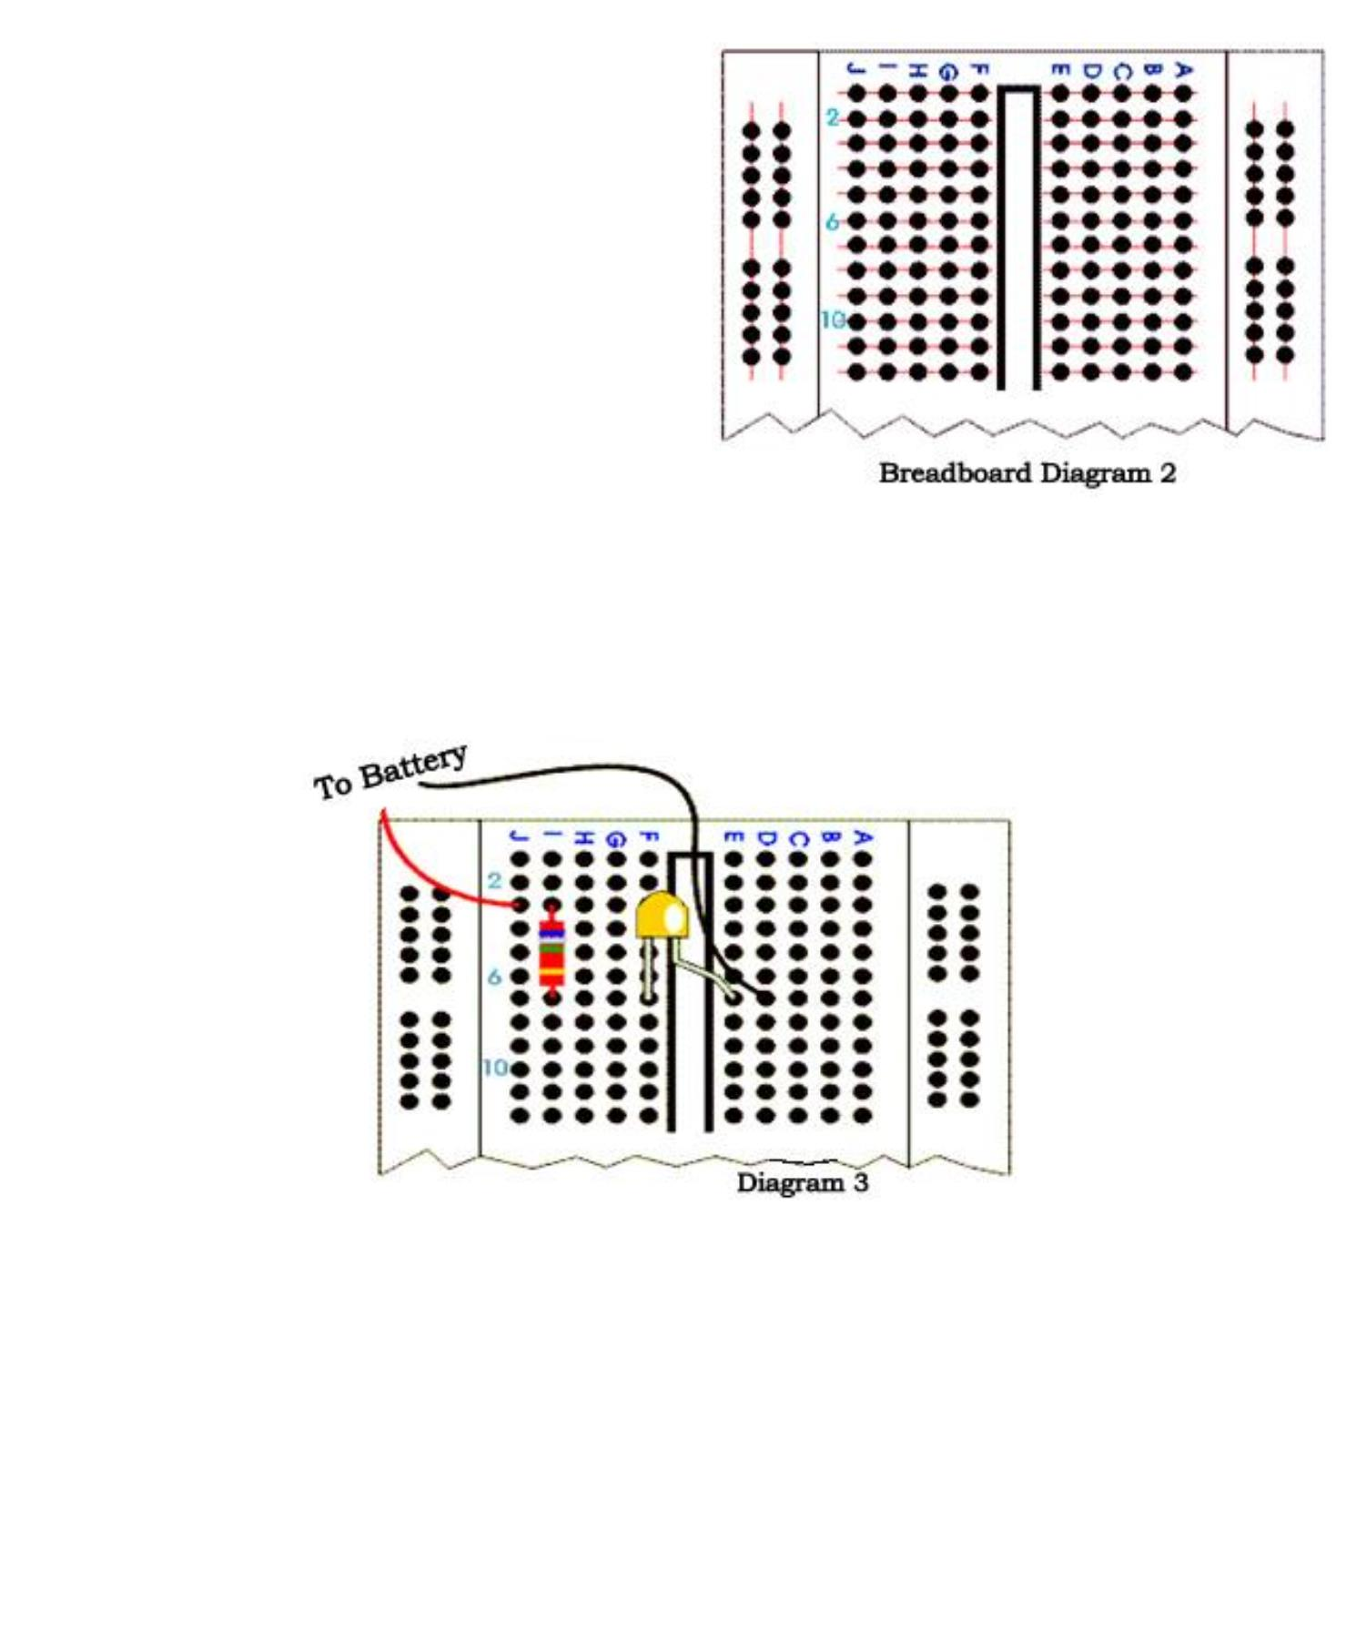
In the below diagram you can see both the vertical columns and horizontal to be connected internally. As soon as the power
is turned on, the current flows through these internal connections.
In the below diagram you can see how a resistor of 380 ohm and a LED are set up on the breadboard. A 9 volt battery is
eventually attached to the LED light. Replace the current resistor with a resistor having 680 ohm you can see the resistance
to be greater and the LED light to be dimmer.
Breadboard Connections:
A breadboard as mentioned before is used to make temporary circuit for testing and other purposes. The advantage of using
a breadboard for testing is that connection can be changed if they are wrong. Also the parts of the circuit do not get
damaged and can easily be reused. A breadboard generally consists of lots of holes so that wires can easily be pushed in.
testing for almost every electronic projects starts from the breadboard. The breadboard has many tiny sockets likes holes
arranged in a 0.1 grid. The leads that most elements have can easily be pushed inside these holes. The ICs are pushed
inside across to the gap with their dot on the left. Standard wires cannot be used for breadboard as they get damaged easily
and hence they require single core plastic coated wires that have 0.6mm diameter. Standard wires if used can also lead to
damage of the board.
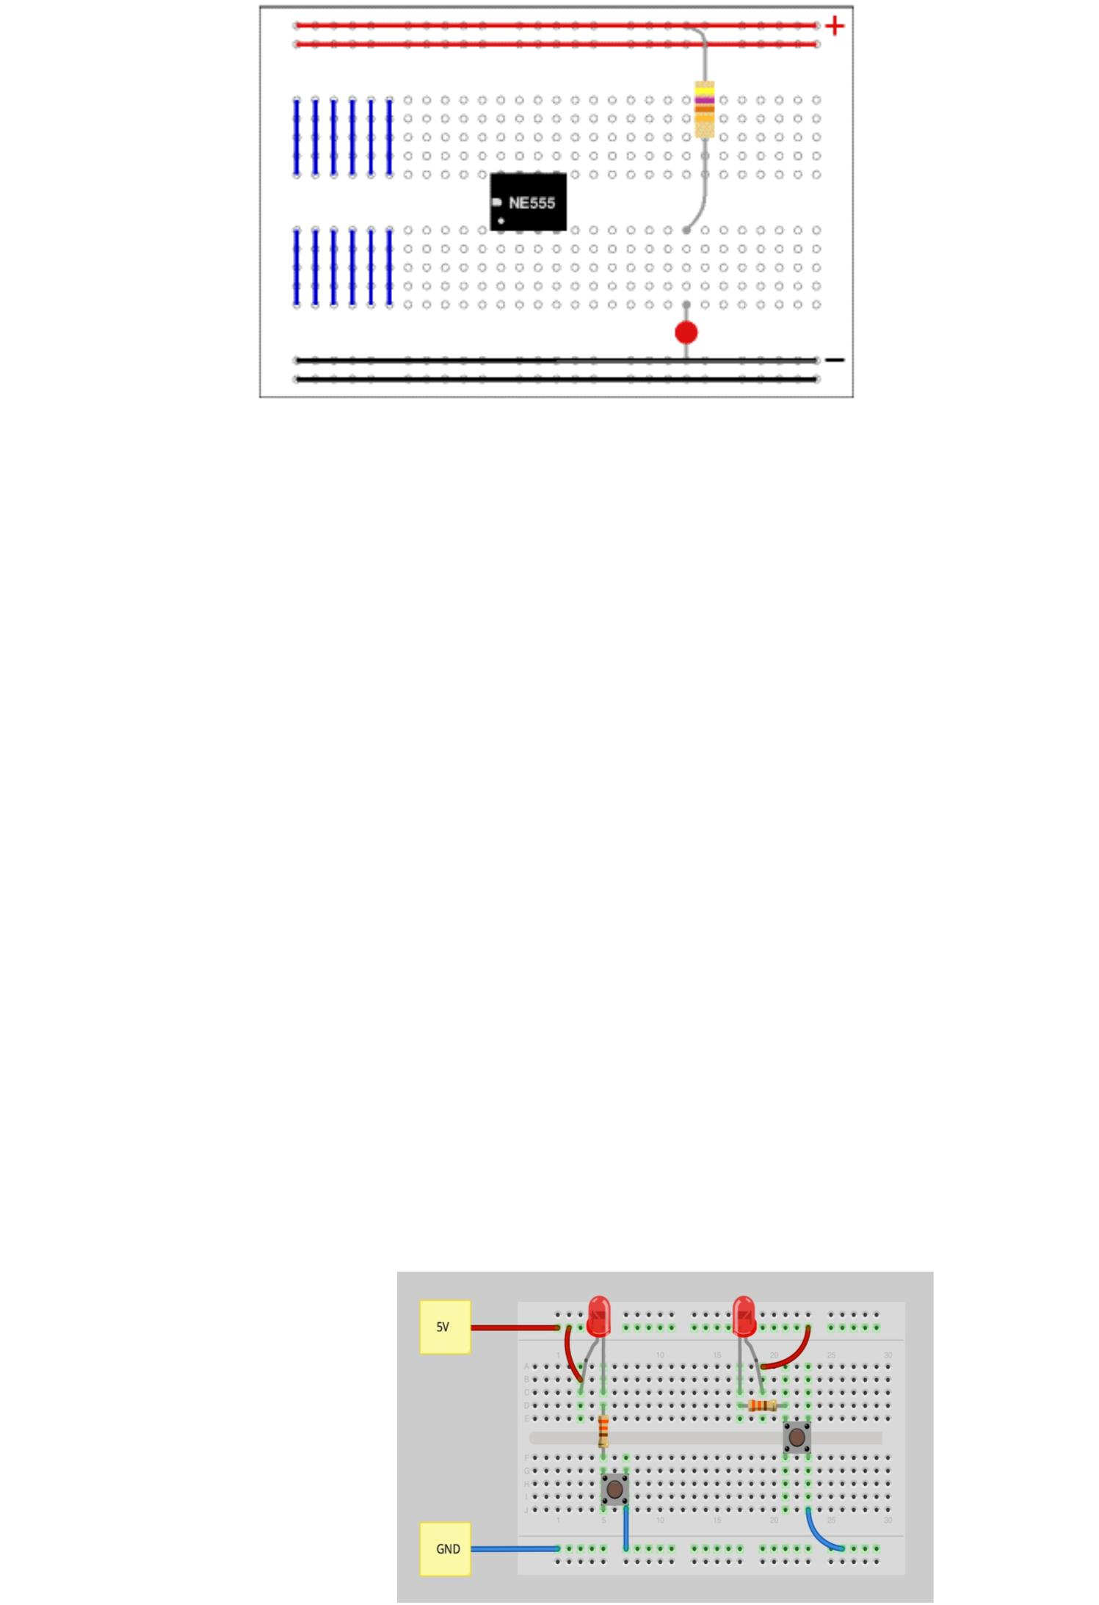
The above diagram shows how the holes of a breadboard are connected. The bottom and the top rows are connected
horizontally across as the red and the black line denotes. The power supply is connected to both the black and red rows.
The other rows are connected in a vertical manner which consists of five rows each without any links to the across the
centre. In this way there are separate blocks of connections to each of the ICs pin. Now this was the connection in a small
breadboard.
In case of large breadboards, there are breaks half way in the top and the bottom rows of the power supply. It is always
better to link across the gap before you start building circuit. If you do not link it then that part of the circuit will not have any
power supply.
Virtual Breadboard:
The virtual breadboard is generally used to test and design embedded software that is in a high level interactive circuit. It is
used for prototyping the hardware from these designs. People find the virtual breadboard easier to utilize than the normal
ones because it has a high approach. Also it is faster in tis working and helps in testing new ideas and circuit variations.
Virtual breadboards are usually used in place of real breadboards because they are fast in working. Also it is fast in
performing experiments and testing electronic embedded applications. Many experimenters prefer using virtual boards for
experiments than real boards as its functioning is easy. The virtual board is popular in many universities around the world
since the 1999.
A virtual breadboard is also called as VBB and makes use of microcontrollers featuring Makeable bereadbaord designs. A
virtual breadboard helps in making your projects easier and helps you do your experiments I a simple way. There are
different versions of VBB that are available which users can use according to their need. It is always better to use a virtual
breadboard than a real one as the virtual ones are more reliable. So if you are in a hurry and want immediate results it is
advised that you make use of VBB.
On the whole, using a breadboard is very easy and as it gives immediate results everyone prefers using it for testing
different gadgets and electronic products.

